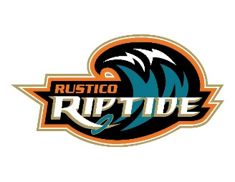Rustico Ringette 

UPDATED with new dates!

2022 WINE ELIMINATION DRAW FUNDRAISER!!

How it works:

* Teams (of 5) are welcome to participate in the Wine Elimination Draw
* Every day beginning **October 24th** there will be individual names randomly drawn and eliminated. Only when **every team members name is drawn is that team eliminated** from the contest
* Eliminated names will be announced on our Rustico Ringette Association Home of the Riptide Facebook **event** page daily.
* The fun part of this draw is even though your name may have been eliminated, you and your team are still in the game as long as you have team members remaining.
* The last 6 teams with members still remaining will be eligible to win. The prizes are to be shared equally amongst the team members.
* Prize amounts & length of fundraiser are based on 85 teams participating and are subject to change.

1st team out gets 5 bottles of wine

Best team name – voted by you! gets 5 bottles of wine

6th place team wins 10 bottles of wine

5th place team wins 25 bottles of wine

4th place team wins 40 bottles of wine

3rd place team wins 75 bottles of wine

2nd place team wins 100 bottles of wine

1st place team wins 165 bottles of wine

What you need to do to participate:

1. Create a team of 5 members (19+) and Give your team a Creative Name
2. Contact Erin at [macraeforrest@hotmail.com](mailto:macraeforrest@hotmail.com) or on FB to register your team and hold your spot.

Please include your team name, members & team captain’s contact information

1. Each team of 5 donates $50 and 5 bottles of wine

** Recommended Minimum wine purchase price $15

** **NO HOMEMADE WINE or Boones**

1. **Drop off your Team’s wine AND money on Saturday October 22 from 9am to 11am at New Glasgow** **Lobster Suppers** – We ask that only one team member drops off ALL wine & money.
2. Final draw will be on Friday December 16th with pick up of prizes on the Saturday morning December 17th.

*All money & wine must be in by October 22nd to be eligible to participate*

*All money donated will go to the Rustico Ringette Association*

*& all 425 bottles of wine will be given away as prizes to the winning teams!!!*